

LAB REPORT 02

SUBMITTED TO : MR. MUBASHIR IQBAL
SUBMITTED BY: AHMED SALEEM RANA
REG ID: 24-CYS-023
SECTION : B
COURSE TITLE: ARTIFACIAL INTEELLIGENCE LAB

HITEC UNIVERSITY, TAXILA CANTT

TASK 01

Count the number of strings where the string length is 2 or more and the first and last character are same from a given list of strings. Sample List: [‘abc’, ‘xyz’, ‘aba’, ‘1221’, ‘xyzzyx’, ‘aa’, ’122’] Expected Result: 4 .

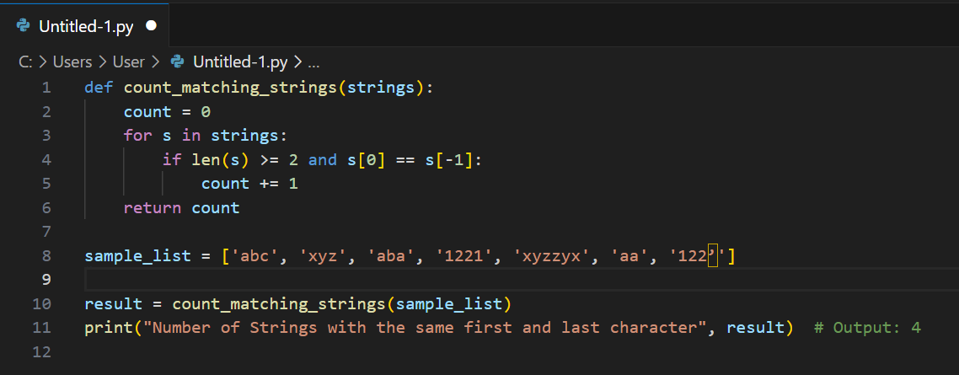
INPUT:

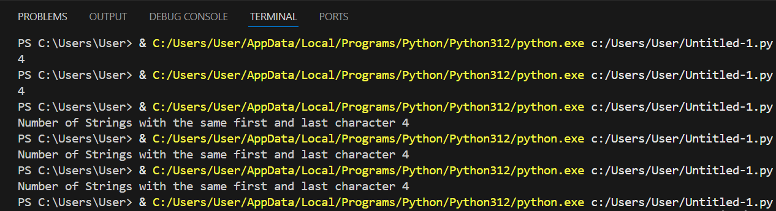
OUTPUT:

TASK 02

Find the sum and product of numbers in a tuple. Sample List: (1,2, 4, 2, 6), Sum is: 15, Product is: 96.
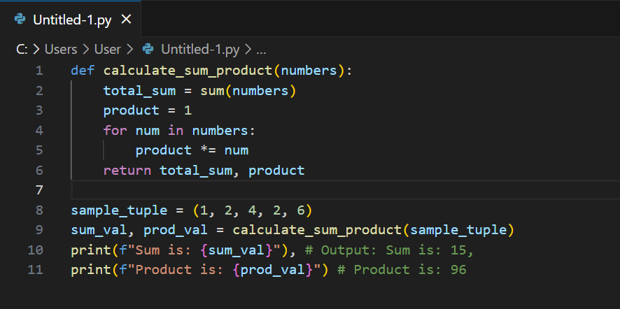
INPUT:
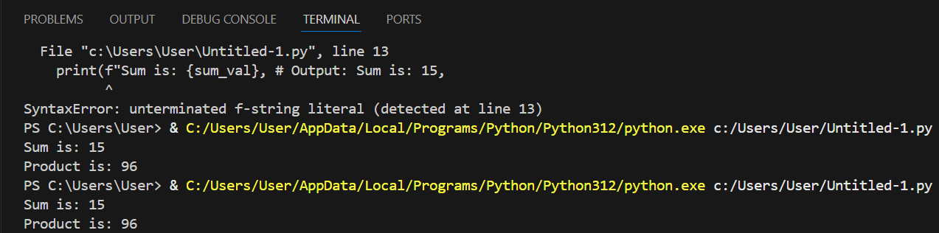
OUTPUT:

TASK 03

Write a program to print largest number in a List Sample List:
(1, 2, 4, 2, 6).
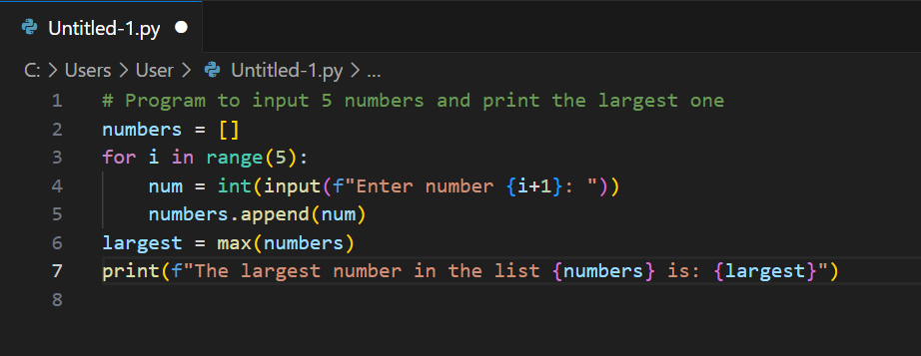
INPUT:

OUTPUT:
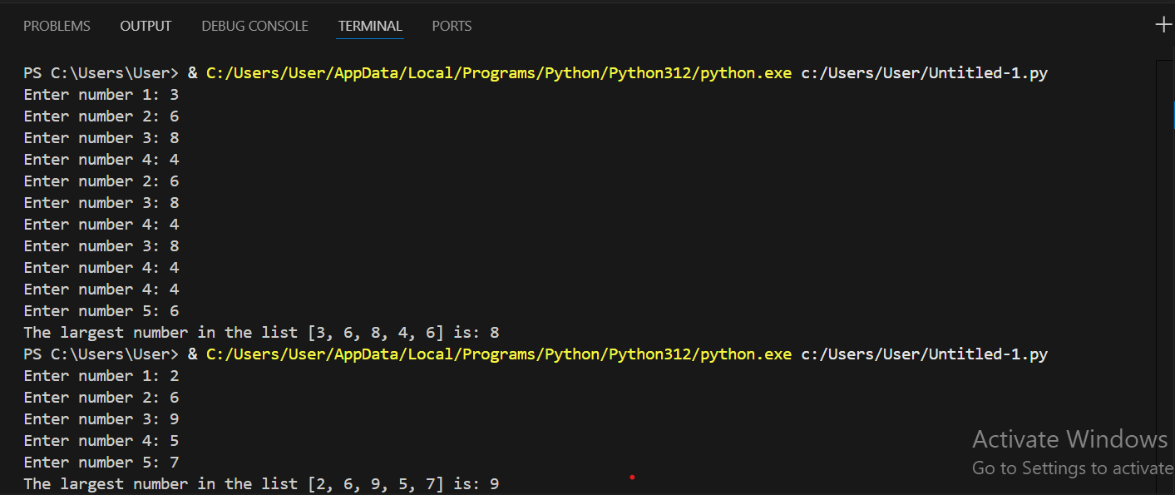

TASK 04
Write a Python program to remove an empty tuple(s) from a list of tuples. Sample L = [(), (), ('',), ('a', 'b'), (), ('a', 'b', 'c'), (), ('d')], Result = [('',), ('a', 'b'), ('a', 'b', 'c'), ('d')]

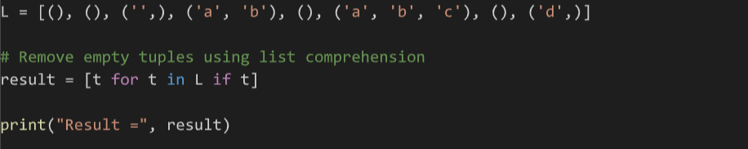
INPUT:

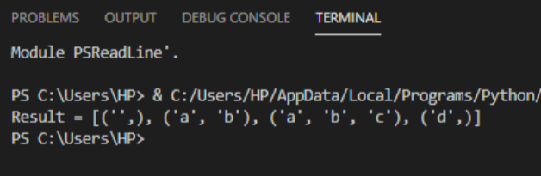
OUTPUT:

TASK 05

Write a Python script to generate and print a dictionary that contains a number (between 1 and n) in the form (‘x’, x*x). Sample: Input a number 4 Output: {‘1’: 1, ‘2’: 4, ‘3’: 9, ‘4’: 16}.

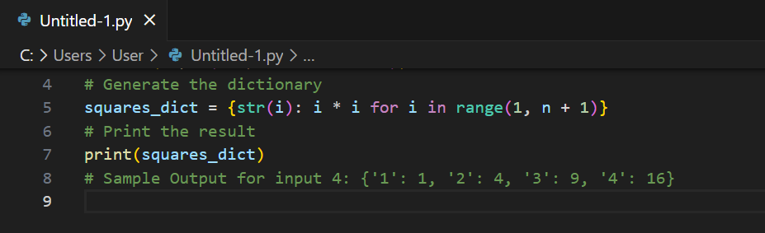
INPUT:

OUTPUT:
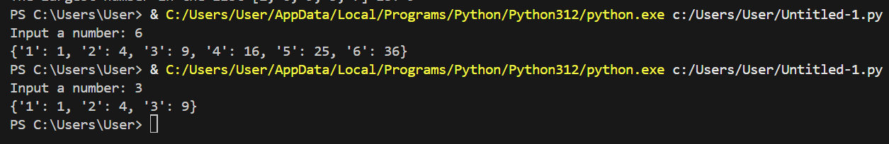

TASK 06

Create a program using Dictionary that takes Numbers as input and print it in words form Sample: Input: 1234, Output: One Two Three Four.

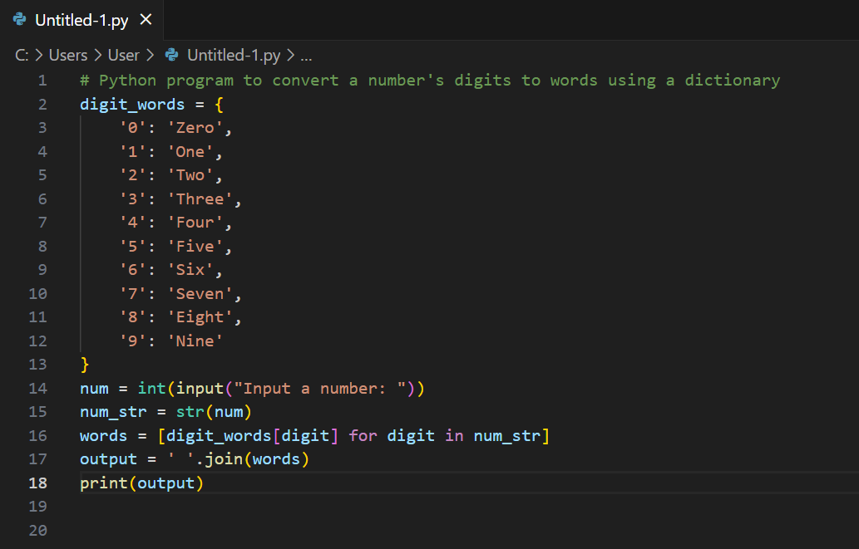
INPUT:

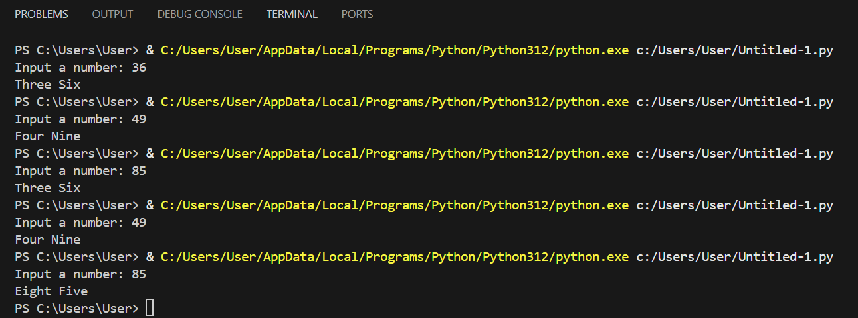
OUTPUT:

CONCLUSION:
In this lab, we have learned on how to work with lists, tuples, and dictionaries in Python programming language. We have learned how to perform pecific operations like removing empty tuples, calculating sum and product, finding the largest number, counting strings, converting numbers into various words as well as generating various square dictionaries.
We have been able to improve our basic understanding of if-else conditions, loops along with data structures like lists etc. This has resulted in improving the logical thinking and applying python concepts to solving real world problems.

